Farm animals
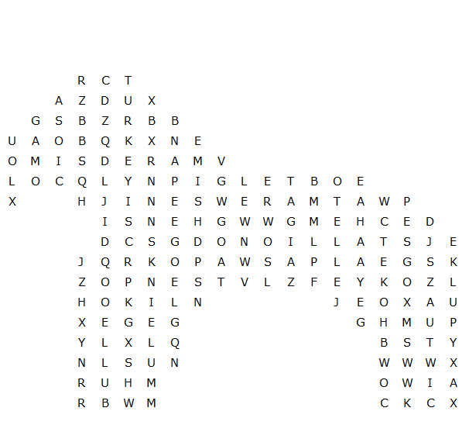

stallion gosling chicken donkey piglet turkey
horse sheep goose lamb bull mare mule
calf goat cow pig sow ram ewe hen

Farm animals – solution
